Final AHP Validation Report

1. Objective
The Analytic Hierarchy Process (AHP) was employed to determine the relative importance of the factors contributing to the Smart Waste Severity Index (SWSI). This validation report verifies the pairwise comparison matrix, normalized matrix, criteria weights, and consistency measures to ensure reliable weight assignment for waste severity assessment.

2. Criteria Considered
The following criteria were used in the AHP analysis:
- Waste Count (WC)
- Waste Type Weight (WTW)
- Location Sensitivity (LS)
- Historical Frequency (HF)

3. Pairwise Comparison Matrix
Criteria | WC | WTW | LS | HF
Waste Count (WC) | 1 | 2 | 3 | 4
Waste Type Weight (WTW) | 1/2 | 1 | 2 | 3
Location Sensitivity (LS) | 1/3 | 1/2 | 1 | 2
Historical Frequency (HF) | 1/4 | 1/3 | 1/2 | 1
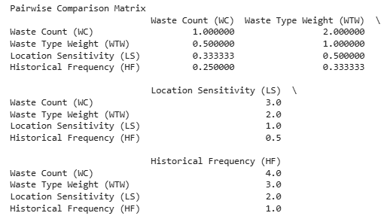

4. Column Sum Calculation
Column | Sum
WC | 2.0833
WTW | 3.8333
LS | 6.5000
HF | 10.0000
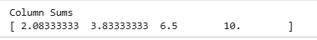

5. Normalized Pairwise Comparison Matrix
Criteria | WC | WTW | LS | HF
WC | 0.4800 | 0.5217 | 0.4615 | 0.4000
WTW | 0.2400 | 0.2609 | 0.3077 | 0.3000
LS | 0.1600 | 0.1304 | 0.1538 | 0.2000
HF | 0.1200 | 0.0870 | 0.0769 | 0.1000
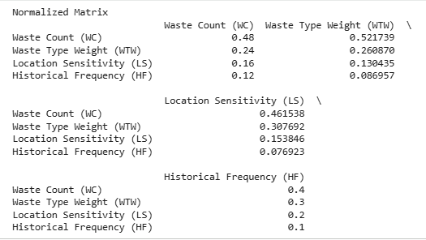

6. Criteria Weight Computation
The criteria weights were obtained by averaging the normalized values across each row.
Criterion | Weight
Waste Count (WC) | 0.4658
Waste Type Weight (WTW) | 0.2771
Location Sensitivity (LS) | 0.1611
Historical Frequency (HF) | 0.0960
Total Weight = 1.0000
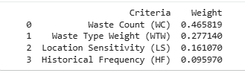

7. Final Approved SWSI Weights
The validated criteria weights adopted throughout the Smart Waste Severity Index framework are:
Criterion | Final Weight
Waste Count | 46.58%
Waste Type Weight | 27.71%
Location Sensitivity | 16.11%
Historical Frequency | 9.60%
These weights shall remain consistent across:
- Research Paper Draft v5
- SWSI Methodology Documentation
- Dashboard Documentation
- Presentation Slides
- GitHub Repository
- Traceability Matrix

8. Consistency Verification

8.1 Weighted Sum Vector
Criterion | Value
WC | 1.9048
WTW | 1.1288
LS | 0.6487
HF | 0.3857

8.2 Maximum Eigenvalue (λmax)
λmax = 4.0310
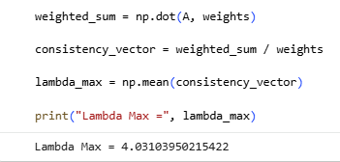

8.3 Consistency Index (CI)
CI = (λmax − n) / (n − 1)
CI = (4.0310 − 4) / 3
CI = 0.01035
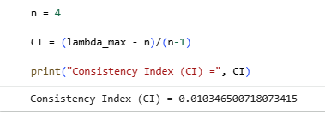

8.4 Consistency Ratio (CR)
Random Index (RI) for n = 4:
RI = 0.90
CR = CI / RI
CR = 0.01035 / 0.90
CR = 0.0115
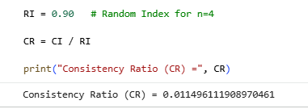

9. Validation Results
Validation Item | Status
Pairwise Comparison Matrix Verified | PASS
Normalized Matrix Verified | PASS
Criteria Weights Verified | PASS
Weight Sum Equals 1.0 | PASS
λmax Computed | PASS
CI Computed | PASS
CR Computed | PASS
CR < 0.10 Requirement | PASS
Cross-Document Consistency Verified | PASS

10. Conclusion
The Analytic Hierarchy Process (AHP) validation confirms that the pairwise comparison matrix used for Smart Waste Severity Index (SWSI) computation is logically consistent and statistically reliable. The resulting weights were determined as 0.4658 for Waste Count, 0.2771 for Waste Type Weight, 0.1611 for Location Sensitivity, and 0.0960 for Historical Frequency. Consistency verification produced λmax = 4.0310, CI = 0.01035, and CR = 0.0115. Since the Consistency Ratio is significantly below the accepted threshold of 0.10, the judgment matrix is considered highly consistent. Therefore, the derived weights are validated and approved for use throughout the Smart City Garbage Analytics Framework.

